Flipped Classroom
Teacher: Ms Vallanka Dias
Department of Biotechnology
Course: Plant and Animal Physiology
Topic: Plant Hormones
Introduction:
The students are given the responsibility of teaching and learning while the faculty monitors the process and ensures smooth functioning.

Objective of the Practice:
- Develop teamwork
- To encourage the students to refer to legit sources of information.
- To inculcate the process of making notes for themselves using the references.

Procedure:
Pre Activity Work
- Making the groups and assigning the topics.
- Students are required to refer to the said reference book before the commencement of the activity.

Activity:
- An activity was conducted for the course of Plant and Animal Physiology (SYBSc, Biotechnology)for the topic of Plant Hormones.
- 28 students were divided into 5 groups. Ecah group was assigned one plant hormone to study in depth (Sub-topics were specified) using reference books. The students were given one hour for this work.
* Each student in a particular group is supposed to ensure that he/she has all the discussed material in writing with adequate referencing.
- In the following hour the groups are shuffled in such a way that every group will have at least one representative of each hormone. In these newly formed groups each student acts as an expert. He/She has the responsibility to explain the hormones studied by him/her to the rest of the group members.
- Towards the end of the session all the group members will have the information about all the hormones.

Post Activity:
- Checking the authenticity of the information shared.
- Documenting the notes neatly.

Outcomes:
Teachers Perspective
- The students were more engaged and they felt more responsible since they were to explain to others in the second part of the activity.
- Students had familiarized themselves with using reference books rather then just relying on the information given by the teacher.
- The students were more disciplined as they had structured the flow of information.
Students Perspective:
This is better than the traditional methods of teaching because the students get a chance to be interactive. It is proved that teaching someone else helps us understand the concept better and to enjoy it as well.
- By Shreesidhi Bhomkar, SYBSc Biotechnology
i)These activities were very useful as they helped us focus and study at least one topic thoroughly.
ii) Knowing that we were going to share our information with other classmates made us even more determined to understand the concepts of hormones that we were working on so that we could explain it to each other in a very simple but detailed manner.
iii) Although we had to self study for these activities, videos were uploaded by our teacher that made our job easier (because I personally believe that visual and auditory learning works best!).
iv) At the end of the activities we all learnt a lot about all the five hormones
v) These activities made our job so much easier for our CAs and Semester end exams.
- By Scimran Da Costa, SYBSc Biotechnology

Problems:
- There were instances of the groups getting chaotic and noisy.
- All the group members had not done the assigned task appropriately.
- All the students do not have good skills in explaining their information.

Think Pair Share
Teacher: Ms. Madhavi M. Motankar

Department of Biotechnology
Course: Tools and Techniques
Topic: Plant Hormones
Objective
1. To develop critical analytical thinking skills
2. To develop self learning and sharing and understanding the solutions.
3. To develop teamwork and make students confident in solving higher order mcqs

Pre-activity
Students were asked to read and study the above mentioned topics and come prepared for class

Activity
- Each student was given the activity sheet with 20 MCQs of higher order thinking level usually asked in Entrance exams (JNU, IISC, SET, CSIR-NET, IIT Phd Entrance, DBT-JRF, DBT-Inspire, etc.)
- Individually students had to solve the MCQs in 15mins and then each one had to pair up with another student and discuss and solve the Qs.
- Once this was done in 10mins the pairs were then assigned in groups of 4 and discussed each Q with solution along with reasoning.

Outcomes
- Students will be able to attempt and solve the Higher Order Thinking level MCQs with confidence.
- Develop critical skills and team work as well as resourceful learning.
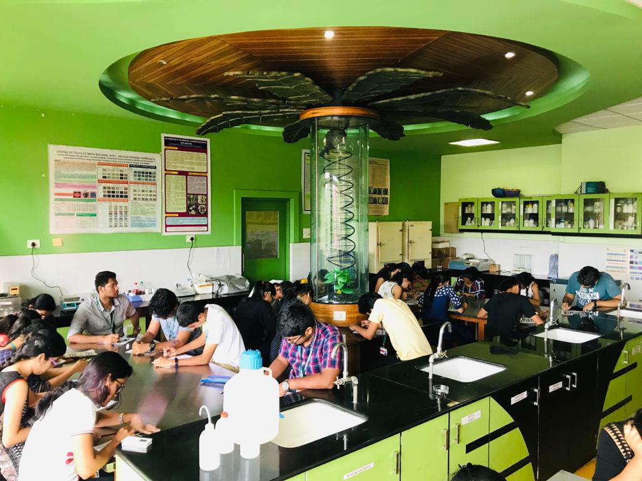
Students participating in Think Pair Share Activity

One Stray Method
Teacher: Ms. Madhavi M. Motankar

Department of Biotechnology
Course: Advanced Microbiology
Topic: Role and Significance of microorganisms in food
Objective
1. To develop critical analytical thinking skills
2. To create a teaching learning environment amongst students
3. To develop teamwork and sharing qualities with confidence

Procedure
Pre-activity
1) Students were expected to see the uploaded videos of ‘Role and significance of microbes’ and read the pdf on ‘history of food Microbiology’ uploaded on google class and come prepared for class
2) 24 Students were distributed in groups named ‘Algae’ ‘Bacteria’ and ‘Fungi’.

Activity
1. Each student of the group was asked to contribute the names and importance of microbes in food and it’s role
2. One student from each group was asked to join the other group so that each group had one student from Algae and Bacteria and Fungi
3. These groups of students were given a blank sheet wherein they were asked to list the names of microbes alongwith their role and significance and this sheet was then shared with all.

Outcomes:
Students were able to share their knowledge with confidence. Also, develop critical skills and team work as well as resourceful learning.

